Marketing Project
Courtney LeCours
October 7th, 2011
Instruction Strategies II
Dr. Louise McCormack
Overview
of the
Project

Overview

Rational

Goals/Objectives

Event Information

Description of Events
Overview

“Surviving Life Field Day” is a day full of events that will test the students’ ability on life skills and making healthy choices. Students will be challenged mentally, physically, and socially, all while having a few good laughs and the applying health concepts that the students have learned over the years.

Rational

When students are given the chance to apply their knowledge they have learned the chances of the students using such information in the real-life settings will increase. That is why activity days, especially “Surviving Life Field Day”, is so important. This day of activities provide real-life scenarios, activity builders, communication and leadership skills, a variety of physical activity, and cognitive celebrations. The stations that the students participate in will cover topics taught over the past three years at West Hernando Middle School, and prepare them for when they leave for the high school next year.

Goals/Objectives

The objective for the students participating in “Surviving Life Field Day” is to apply health concepts to a variety of activities provided by the stations. And of course, continue towards the goal of enjoying physical activity for its health and social benefits.

Event Information

What: “Surviving Life Field Day”
When: May 11th, 2011
Time: 9am – 2pm
Where: Various Locations Around Campus

Description of Events

- Hate On .08
  - Location: Bus Loops

    - Students will move through several obstacle courses and attempt to complete various tasks while wearing impairment goggles.

- Baby Blues
  - Location: Home Economics Room

    - Students will show their skills in child care by participating in a relay race for taking care of babies by using the “Practice Babies” with skills such as feeding, changing diapers, soothing a crying baby, and a few more surprise tasks.

- Cootie Cognition
  - Location: Health Ed Classroom

    - Students will participate as small groups in a trivia challenge about disease health & safety.

- Safety Charades
  - Location: Tennis Courts

    - Students will work in groups of 2 or 3 and act out all of the safety checklists for a variety of activities. Examples could be: riding a bike, driving a car, ect. After students complete that session they will all participate individually in Distraction Disasters, a virtual course that tests students ability to stay focused on the road when riding a bike or driving a car.

- Survivor
  - Location: Nature Trail Activity Course

    - The students must work together, working on their communication & leadership skills to accomplish the Project Adventure course.

- Price Is Right
  - Location: Library Classroom #1

    - Students participate in an eye opening game show that is set up like the “Price Is Right” game show. This activity will test the students’ knowledge of the facts and myths of the amount of sugars and fats that are found in common foods and drinks.

- Zumba
  - Location: Gymnasium

    - Students will participate in Zumba. Zumba is a great physical activity that incorporates fitness and dance.

- Tai Chi
  - Location: Butterfly Garden

    - Tai Chi is a form of physical activity that focuses on stability, balance, and focus. This is a great, self-paced, activity to relieve stress and stay balanced.

- Dental Damage
  - Location: Practice Softball Field

    - The students will work in small groups to race each other and the clock in brushing and flossing giant dirty teeth. *Note – students might get wet*

- Saving Private Ryan
  - Location: Football Field

    - Students will split into groups of four: 2 firefighters & 2 paramedics. The firefighters must work together to maneuver through a “burning building” and rescue a dummy by bring it out to the paramedics. Then paramedics will assess the dummy and will have to perform basic first aid, the Heimlich, or CPR. Once finished, the students will rotate jobs. The key concepts are for the students to demonstrate how to exit a burning house safely and basic life saving skills.

- Snack (x2)
  - Location: Cafeteria

    - Students will enjoy a small, quick, healthy snack that will give them boost for the day.
Action Plan

Master Action Plan

Snack Committee Action Plan

Publicity Committee Action Plan

Builder Committee Action Plansdsaaa22221sq2ercdef,

Guest Relations Committee Action Plan

Event Crew Committee Action Plan

Master Supply List

Master Action Plan
Committee | Contact Person | Objective | Due Date | Check Off
Guest Relations | Local Colleges & Courtney LeCours | Contact local college HHP departments and ask for a student instructors to volunteer his/her time for the event as a Zumba & Tai Chi Instructor | 3/12
Guest Relations | Local Instructors & Courtney LeCours | *If not enough volunteers from the college*  Contact local instructor for class donation and/or find cost | 4/2
Publicity | Courtney LeCours | Design an ad asking about donations and create a list of all local newspaper, community newsletters, ect that could be possible advertisers | 4/9
Guest Relations | WHMS Administration | Contact WHMS for instructor approval | 4/11
Snack | Courtney LeCours | Find 10 easy snacks that do not interfere with allergies of students. | 4/12
Builder | Courtney LeCours & Physical Plant | Come up with safe & affordable pieces of equipment to build that are needed for the event and come up with a supply list | 4/12
Publicity | Advertisers & Courtney LeCours | Contact all selected papers about donating an ad about the event asking for money/equipment donations and vegetable & fruit donations from local farmers | 4/13
Publicity | Party Companies & Courtney LeCours | Find a fog machine donation to be used for 1 day | 4/13
Publicity | Advertisers | Send designed ad to the agreed advertisers | 4/13
Snack | Courtney LeCours | Figure out the amount of ingredients needed for the selected 2 snacks for the activity day | 4/17
Builder | Local Donors & Courtney LeCours | Contact local lumbar yards, hardware stores, ect for donations of needed supplies | 4/17
Event Day Crew | Courtney LeCours | All members turn over information to be cleared to be on campus | 4/18
Snack | Local Farms & Courtney LeCours for assistance | Contact local farms for donations of ingredients for the 2 selected snacks. | 4/23
Builder | Local Donors & Courtney LeCours | Turn in collected donations | 4/23
Builder | Courtney LeCours | Figure the total cost for remaining supplies needed | 4/23

Master Action Plan Continued
Committee | Contact Person | Objective | Due Date | Check Off
Publicity | Advertisers, AAHE, NHAHPERD, Courtney LeCours | Contact the follow to recognize and photograph the students: school yearbook, local newspaper, American Alliance for Health Education (AAHE), and the New Hampshire Alliance for Health, Physical Education Recreation, and Dance (NHAHPERD) | 4/23
Snack | Food Service Manager | *If unable to obtain all ingredients*  Contact the school dining services to ask for assistance | 4/25
Guest Relations | Instructors | Contact instructors to find what will be needed for equipment | 4/27
Event Day Crew | Courtney LeCours | School rules & behavior when on campus, and receive Activity Day Map | 4/29 and 4/30  for those that could not attend the 29th
Builder | Courtney LeCours | *If needed*  Purchase remaining supplies | 4/27
Builder | Physical Plant & Courtney LeCours | Build equipment | 4/30 – 5/3
Snack | Courtney LeCours | *Dependant on the prior two results*  Figure out the total cost for needed ingredients to be purchased | 4/30
Guest Relations | Courtney LeCours | Turn in paperwork of who is coming what is needed | 5/1
Snack | Vendor & Courtney LeCours | Turn in collected ingredients | 5/7
Snack | Courtney LeCours | Make the snacks | 5/10
Snack | Food Services & Courtney LeCours | Distribute snacks inside the cafeteria and make sure the cafeteria is clean afterwards | 5/11
Event Day Crew | Courtney LeCours | Report on time to scheduled station | 5/11
Publicity | Courtney LeCours | *If AAHE and/or NHAHPERD will publish a story* Write an article and select several approved photos to turn in | 5/16

Snack Committee Action Plan
Committee | Contact Person | Objective | Due Date | Check Off
Snack | Courtney LeCours | Find 10 easy snacks that do not interfere with allergies of students. | 4/12
Snack | Courtney LeCours | Figure out the amount of ingredients needed for the selected 2 snacks for the activity day | 4/17
Snack | Local Farms & Courtney LeCours for assistance | Contact local farms for donations of ingredients for the 2 selected snacks. | 4/23
Snack | Food Service Manager | *If unable to obtain all ingredients*  Contact the school dining services to ask for assistance | 4/25
Snack | Courtney LeCours | *Dependant on the prior two results*  Figure out the total cost for needed ingredients to be purchased | 4/30
Snack | Vendor & Courtney LeCours | Turn in the collected ingredients | 5/7
Snack | Courtney LeCours | Make the snacks | 5/10
Snack | Food Services & Courtney LeCours | Distribute snacks inside the cafeteria and make sure the cafeteria is clean afterwards | 5/11

Publicity Committee Action Plan
Committee | Contact Person | Objective | Due Date | Check Off
Publicity | Courtney LeCours | Design an ad asking about donations and create a list of all local newspaper, community newsletters, ect that could be possible advertisers | 4/9
Publicity | Advertisers & Courtney LeCours | Contact all selected papers about donating an ad about the event asking for money/equipment donations and vegetable & fruit donations from local farmers | 4/13
Publicity | Party Companies & Courtney LeCours | Find a fog machine donation to be used for 1 day | 4/13
Publicity | Advertisers | Send designed ad to the agreed advertisers | 4/13
Publicity | Advertisers, AAHE, NHAHPERD, Courtney LeCours | Contact the follow to recognize and photograph the students: school yearbook, local newspaper, American Alliance for Health Education (AAHE), and the New Hampshire Alliance for Health, Physical Education Recreation, and Dance (NHAHPERD) | 4/23
Publicity | Courtney LeCours | *If AAHE and/or NHAHPERD will publish a story*  Write an article and select several approved photos to turn in | 5/16

Builder Committee Action Plan
Committee | Contact Person | Objective | Due Date | Check Off
Builder | Courtney LeCours & Physical Plant | Come up with safe & affordable pieces of equipment to build that are needed for the event and come up with a supply list | 4/12
Builder | Local Donors & Courtney LeCours | Contact local lumbar yards, hardware stores, ect for donations of needed supplies | 4/17
Builder | Local Donors & Courtney LeCours | Turn in collected donations | 4/23
Builder | Courtney LeCours | Figure the total cost for remaining supplies needed | 4/23
Builder | Courtney LeCours | *If needed*  Purchase remaining supplies | 4/27
Builder | Physical Plant & Courtney LeCours | Build equipment | 4/30 – 5/3

Guest Relations Committee Action Plan
Committee | Contact Person | Objective | Due Date | Check Off
Guest Relations | Local Colleges & Courtney LeCours | Contact local college HHP departments and ask for a student instructors to volunteer his/her time for the event as a Zumba & Tai Chi Instructor | 3/12
Guest Relations | Local Instructors & Courtney LeCours | *If not enough volunteers from the college*  Contact local instructor for class donation and/or find cost | 4/2
Guest Relations | WHMS Administration | Contact WHMS for instructor approval | 4/11
Guest Relations | Instructors | Contact instructors to find what will be needed for equipment | 4/27
Guest Relations | Courtney LeCours | Turn in paperwork of who is coming what is needed | 5/1

Event Day Crew Committee Action Plan
Committee | Contact Person | Objective | Due Date | Check Off
Event Day Crew | Courtney LeCours | All members turn over information to be cleared to be on campus | 4/18
Event Day Crew | Courtney LeCours | School rules & behavior when on campus, and receive Activity Day Map | 4/29 and 4/30  for those that could not attend the 29th
Event Day Crew | Courtney LeCours | Report on time to scheduled station | 5/11

Master Supply List
Item | Quantity | Activity | Activity
Hula Hoops | 12 | 12 – Hate On .08
Hula Hoop Stands | 12 | 12 – Hate On .08
Dome Cones | 18 | 18 - Hate On .08
Hot Spots | 18 | 18 - Hate On .08
Gymnastics Mats | 12 | 12 - Hate On .08
Wood Planks | 6 | 6 – Hate On .08
Impairment Goggles | 6 | 6 – Hate On .08
Baby Bottles | 24 | 24 – Baby Blues
Practice Babies | 18 | 18 – Baby Blues
Diapers | 36 | 36 – Baby Blues
Oatmeal | 1 | 1 – Baby Blues
Coco Powder | 1 | 1 – Baby Blues
Water | On tap | Baby Blues
Yellow Food Coloring | 1 | 1 – Baby Blues
Mini Dry Erase Boards | 9 | 6 – Cootie Cognition
Dry Erase Markers | 9 | 6 – Cootie Cognition
LCD | 2 | 1 – Cootie Cognition | 1 – Safety Charades
Laptop | 2 | 1 – Cootie Cognition | 1 – Safety Charades
Frisbees | 18 | 18 – Safety Charades
Extension Cord | 1 | 1 – Safety Charades
Screen/White Sheet | 1 | 1 – Safety Charades
Canopy | 1 | 1 – Safety Charades
Tarp | 1 | 1 - Survivor
Test Tubes | 45 | 45 – Price Is Right
Test Tube Racks | 15 | 15 – Price Is Right
Bag of Sugar | 1 | 1 – Price Is Right
Master Supply List
Item | Quantity | Activity | Activity
Food Labels | 45 | 45 – Price Is Right
Measuring Tool | 1 | 1 – Price Is Right
Chairs/Stools | 3 | 3 – Price Is Right
Sound System | 2 | 1 - Zumba | 1 – Tai Chi
Music | 2 | 1 - Zumba | 1 – Tai Chi
Builder Committee | 2 - 4 | Dental Damage
Scrub Brushes | 18 | 18 – Dental Damage
5ft Pieces of Rope | 4 | 4 – Dental Damage
Buckets | 4 | 4 – Dental Damage
Bottle of Soap | 1 | 1 – Dental Damage
Hose | 1 | 1 – Dental Damage
Caution Tape | 1 Roll | 1 – Saving Private Ryan
Dummies | 4 | 4 – Saving Private Ryan
Fire Fighter Caps | 10 | 10 – Saving Private Ryan
Clorox Wipes | 1 | 1 – Saving Private Ryan
Band-Aids | 1 Box | 1 – Saving Private Ryan
Bottles of Water | 4 | 4 – Saving Private Ryan
Builder Committee | 4 - 8 | 4 - 8 – Saving Private Ryan
Fog Machine | 1 | 1 – Saving Private Ryan
Snacks | 2 Types | 2 - Snacks
Paper Towel Rolls | 5 | 5 - Snacks
Windex | 1 | 1 - Snacks

Communication

Consent Form

Permission To Administration

Thank You Letters to Volunteers

Thank You Letters to Teacher Volunteers

Student Certificate

Volunteer Certificate

Diagrams of Stations
West Hernando Middle School’s

“Surviving Life Field Day”
Consent Form

Dear Parent(s)/Guardian(s),

It’s that time of year again when our 8th graders come together and test their skills from Health class that they have learned over the past three years at West Hernando. The students will participate in a variety of health-concept based activities that challenge them mentally, physically, and socially.

We are sending this consent form to both inform you and to request permission for your child to participate in the activities and for your child’s photo/image and personally identifiable information to be published on the district and/or school’s web site.

Please check one of the following choices:

___ I/We GRANT permission for a photo/image that includes this student without any other personal identifiers to be published on the school and/or district’s public Internet site.

___ I/We GRANT permission for this student’s photo/image and name to be published on the school and/or district’s public Internet site.

___ I/We DO NOT GRANT permission for photo/image that includes this student to be published on the school and or district’s public Internet site.

Also, in one of the activities, there will be water involved so your child may get wet. Please make sure your child brings a change of clothes, socks, and shoes incase it is needed. If you would like to be a part of this learning experience, please fill out the back side of this form, thank you.

Date: _______________

Student’s Name: (print) _________________________________

Print name of Parent/Guardian: (print) ____________________________________

Signature of Parent/Guardian: (sign) _____________________________________

Any Allergies/Health Concerns: _________________________________________

Dietary Restrictions: __________________________________________________

http://www.nj.gov/education/techno/idconsent/form.pdf

There are several committees in which we would love for you to be a part of, and would help the school out tremendously. Remember that you can be as much involved as you would like!

Please circle and/or check each committee that you would like to volunteer for.

Snack

- The Snack Committee will be in charge of contacting local farms to ask for donations. If there are no donations available, you will contact me so that I will be able to make other plans with our food services. Also, the committee will come up with several ideas, which will have to be approved, for the two snack times during the activity day, that honor any dietary restrictions of the students.

Set-Up Crew (8:15 – 8:45am day of the event)

- The Set-Up Crew is responsible for gathering the equipment and setting up the activity as designed prior to the start of the event.

Takedown Crew (2 – 2:30pm day of the event)

- The Take-Down Crew is responsible for gathering and returning the equipment to the gymnasium, as well as sorting it into its’ correct pile. And making sure that the activity areas are cleaned up.

Builders

- The Builder Committee will be in charge of creating any needed props or décor/scenery that will be needed for the activities. In addition, the committee will also have to call local areas to ask for supply donations if needed.

Publicity

- The Publicity Committee will be in charge of flyers, contacting the newspaper and yearbook, as well as any other marketing necessary for the event.

Activity Leaders

- The Activity Leaders will be in charged of leading the activities that the students will participate in. Some of the responsibilities may include but are not limited to: giving the activity instructions to the students, supervising and aiding in the activity, and giving a closing discussion at the end of each activity.

8:45 – 11am _____ 11 – 1pm _____ 1 – 2pm _____

Permission to Administration

Dear Principal ________________,

With a coming to another end of year celebration of our eighth grades moving forward to the high school, it is pertinent that they recall, and practice, key health components that will help ensure their wellness outside of our walls.

This is why I purpose that May the 11th; our eighth grade students participate in a “Surviving Life Field Day” that incorporates the health components that had been learned over the course of their time at West Hernando Middle School. It will be a great way to reinforce positive, healthy, behaviors to our students. In addition, the family members of the students are greatly encouraged to be a part of the learning and structural process, thus integrating the community into our school’s wellness goals as well.

For further information, there is an action plan attached and I am available for any addition questions or concerns.

Sincerely,

Courtney LeCours

________________________
Thank You Letter to Volunteers

Dear ___________,

I would like to personally say thank you for all of the work that you have put forth in making “Surviving Life Field Day” such a successful event! All of the students had an amazing time and took the experiences that they had gained to heart. The faculty and staff of West Hernando Middle School were completely overjoyed in the participation of those from the students’ family.

Because of your work with the ____________ Committee, this day of learning was an optimal experience. All of the time you have spent working diligently to make this day meaningful will hopefully transform into skills that the students will use went entering the high school next year. Again, I would like to thank for being a part of the West Hernando Family, and that this event would not of have been as successful without you.

Sincerely,

Courtney LeCours
Physical & Health Educator

_______________________________

Thank You Letter to Teacher Volunteers

Dear ___________,

I would like to personally say thank you for all of the work that you have put forth in making “Surviving Life Field Day” such a successful event! All of the students had an amazing time and took the experiences that they had gained to heart. The family members and students were thrilled to see the school come together to make a special day for the students.

Because of your work with the ____________, this day of learning was an optimal experience. All of the time you have spent working diligently to make this day meaningful will hopefully transform into skills that the students will use went entering the high school next year. Again, I am truly grateful to know that you are a part of the West Hernando Family, and I am certain that the students feel the same way.

Sincerely,

Courtney LeCours
Physical & Health Educator

_______________________________

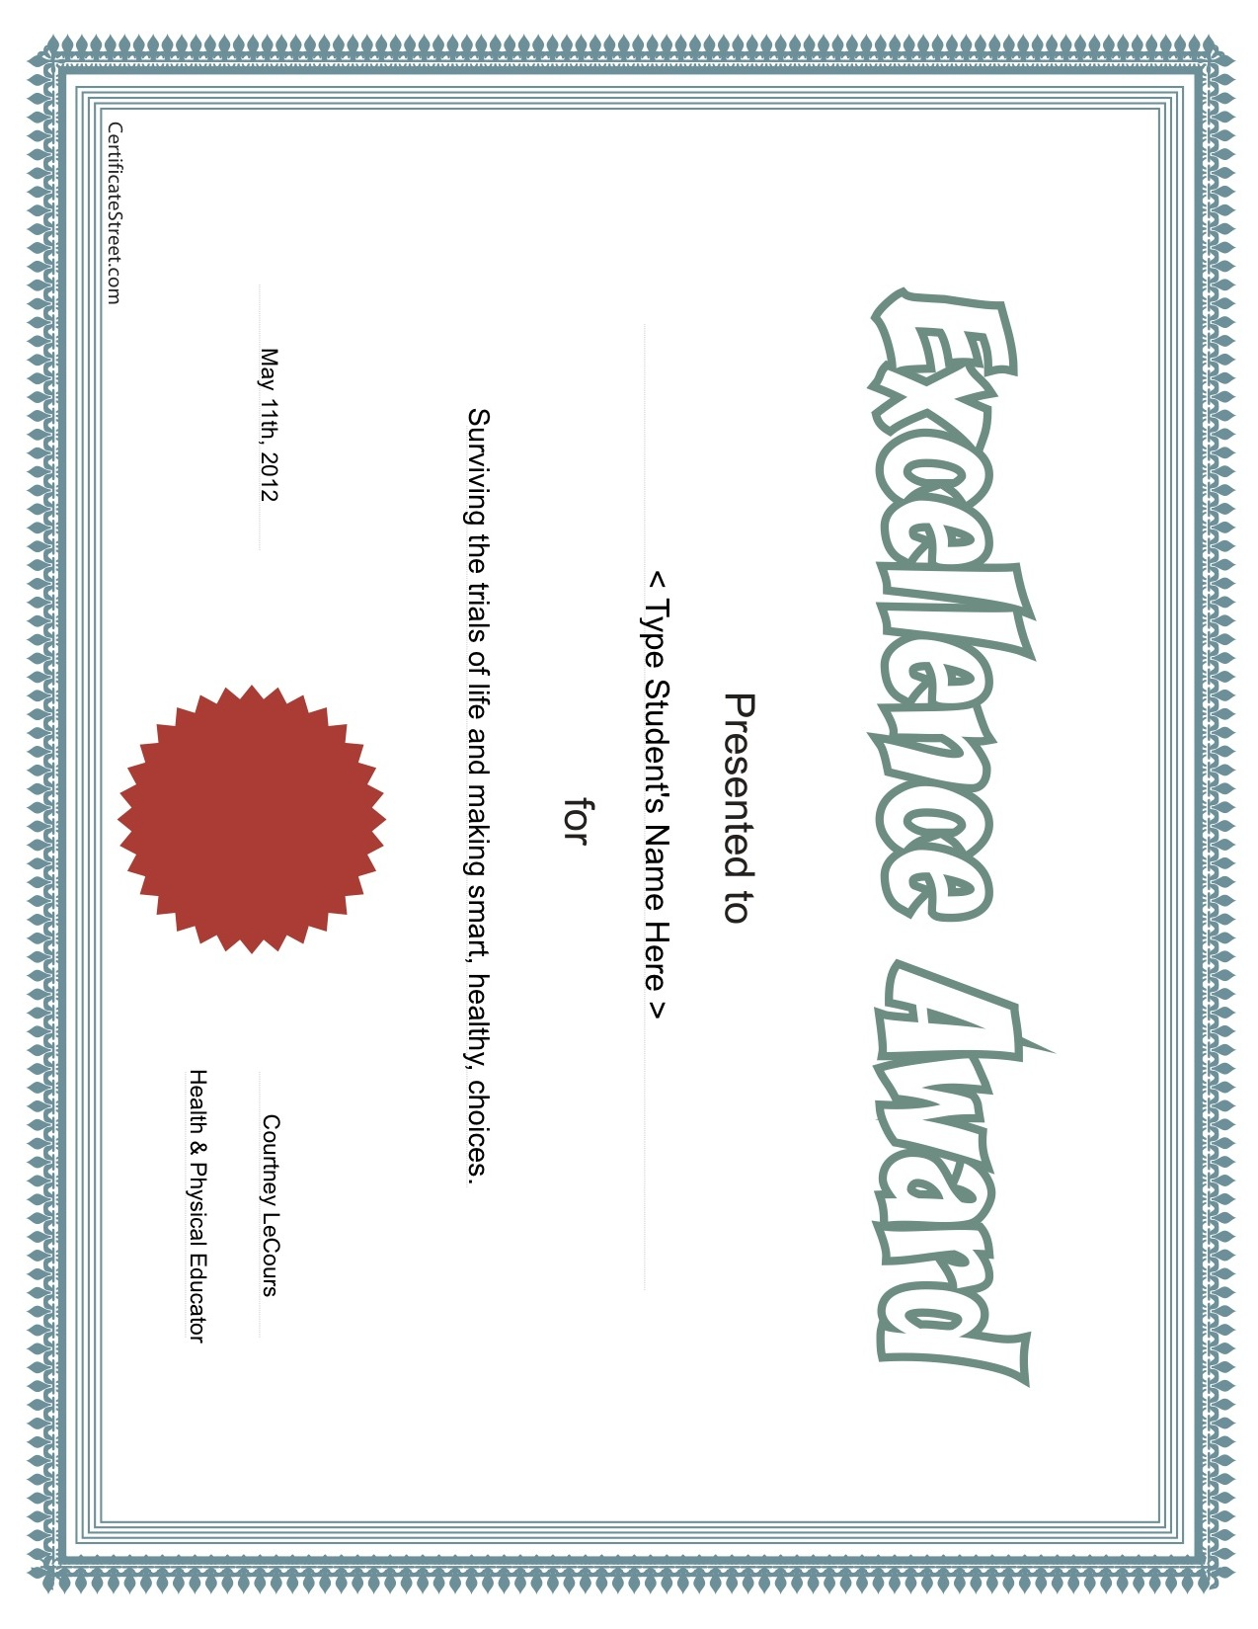

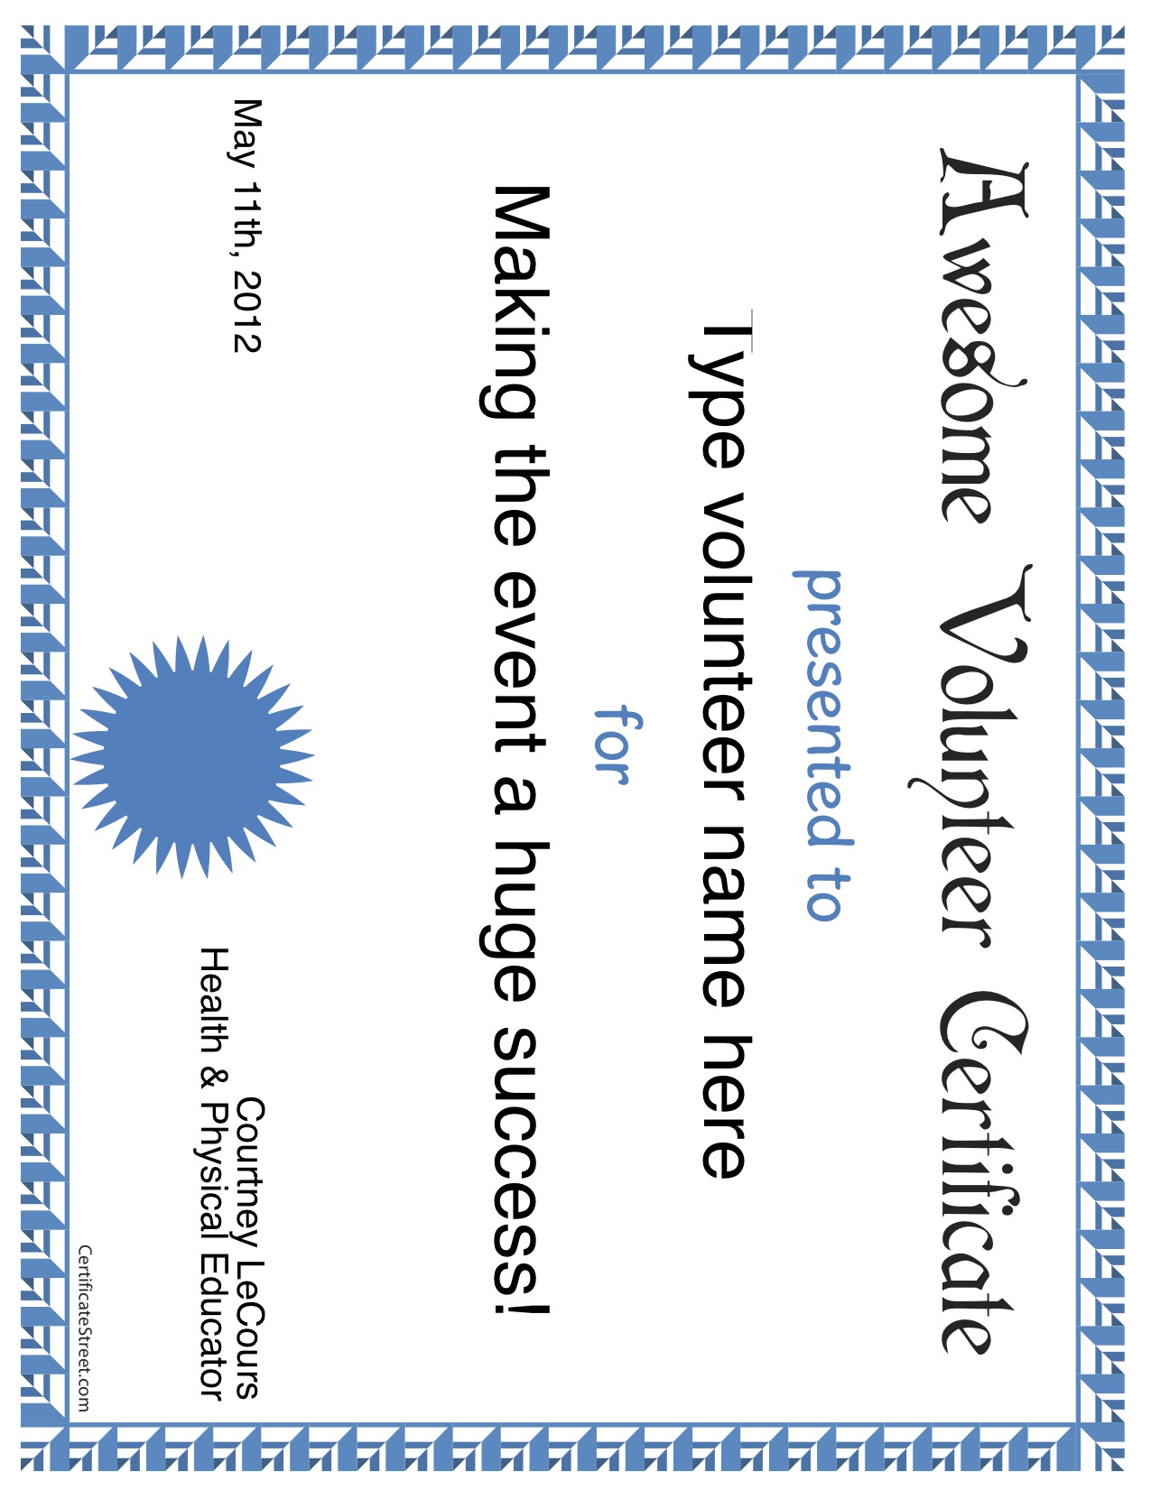

Diagrams of Stations

Hate On .08

Baby Blues

Cootie Cognition

Safety Charades

Survivor

There are Project Adventure activities throughout the nature trail that the student will be able to participate in. There will be an addition activity using a tarp as an introduction activity.

Price Is Right

Zumba

Tai Chi

Dental Damage

Saving Private Ryan

Event Set-Up

Agenda

Maintenance

Training

Security/Safety
Agenda

Event Day Agenda
Time | Task
7:45 – 8:15 | Organize equipment to be brought to stations
8:15 - 8:45am | Setting up stations
8:45 – 8:50am | Activity Leader Briefing
8:50 – 9am | Activity Leaders move to stations, settles down, and waits for students to arrive  AND  Students receive Snack #1 in homeroom
9 – 9:20am | Rotation 1
9:20 – 9:25 | Transition
9:25 – 9:40am | Rotation 2
9:40 – 9:45 | Transition
9:45 – 10:05 | Rotation 3
10:05 – 10:10 | Transition
10:10 – 10:30 | Rotation 4
10:30 – 10:35 | Transition
10:35 – 10:55 | Rotation 5
10:55 – 11 | Transition to lunch
11 – 11:30am | Lunch
11:30 – 11:35 | Transition
11:35 – 11:55 | Rotation 6
11:55 – 12pm | Transition
12 – 12:20 | Rotation 7
12:20 – 12:25 | Transition
12:25 – 12:45 | Rotation 8
12:45 – 12:50 | Transition
12:50 – 1:10 | Rotation 9
1:10 – 1:15 | Transition
1:15 – 1:35 | Rotation 10
1:15 – 1:20 | Transition to Study Hall
1:20 – 1:40 | Snack #2 & the end of Field Day

Maintenance

To ensure the safety of the environment and equipment, several checks will be made. The day before and morning of, the environment will be checked for any trash, holes, and other hazards that may harm the participants. The equipment will also be checked to ensure that it is all working properly.

Training

All those who are volunteering to participate during the actual field day event will be required to attend a training session. This training will include but not limiting to: school policies; expected behavior and professionalism; activity format, and tips on teaching strategies.

Security/Safety

All volunteers that will be on campus during the event day will be checked through administration to ensure that he or she is allowed on campus. For further security, the school’s resource officer will also be making rounds throughout the day.
Event Evaluation

Evaluation Processes

Student Evaluation

Volunteer Evaluation

Process of Evaluation

- Students Evaluations

  - Administered:
    - The following school day during Homeroom

  - Submitted:
    - Collected from the Homeroom teacher after completion

- Volunteer Evaluations

  - Administered:
    - During the last committee meeting

  - Submitted:
    - Brought to school by his or her student by May 18th
    - Turned into Ms. LeCours, Health Educator.
Student Event Evaluation

Thank you for taking the time to complete this survey about our “Surviving Life Field Day”. The information gathered will help us make next year’s event even more successful!

Please circle the number that you feel best fits the statement:
1 = completely disagree, 3 = Neutral, 5 = completely agree.

- The event had a variety of activities
1 2 3 4 5

- The event was well organized
1 2 3 4 5

- The activities were well connected to the health concepts in class
1 2 3 4 5

- The time spent at each activity was just right
1 2 3 4 5

- I enjoyed Zumba
1 2 3 4 5

- I enjoyed Tai Chi
1 2 3 4 5

Any other comments?

Volunteer Event Evaluation

Thank you for taking the time to complete this survey about our “Surviving Life Field Day”. The information gathered will help us make next year’s event even more successful!

Please circle the number that you feel best fits the statement:
1 = completely disagree, 3 = Neutral, 5 = completely agree.

Please have your student return this for to his or her Health Teacher by May 20th.

- The committees were well organized
1 2 3 4 5

- Assignments were asked to be completed in a timely manor
1 2 3 4 5

- The responsibilities asked were reasonable
1 2 3 4 5

- Directions and/or tasks were clear and concise
1 2 3 4 5

Please add any additional comments or information that may help the program in the future.

Publicity
&
Marketing

Flyer

Newsletter

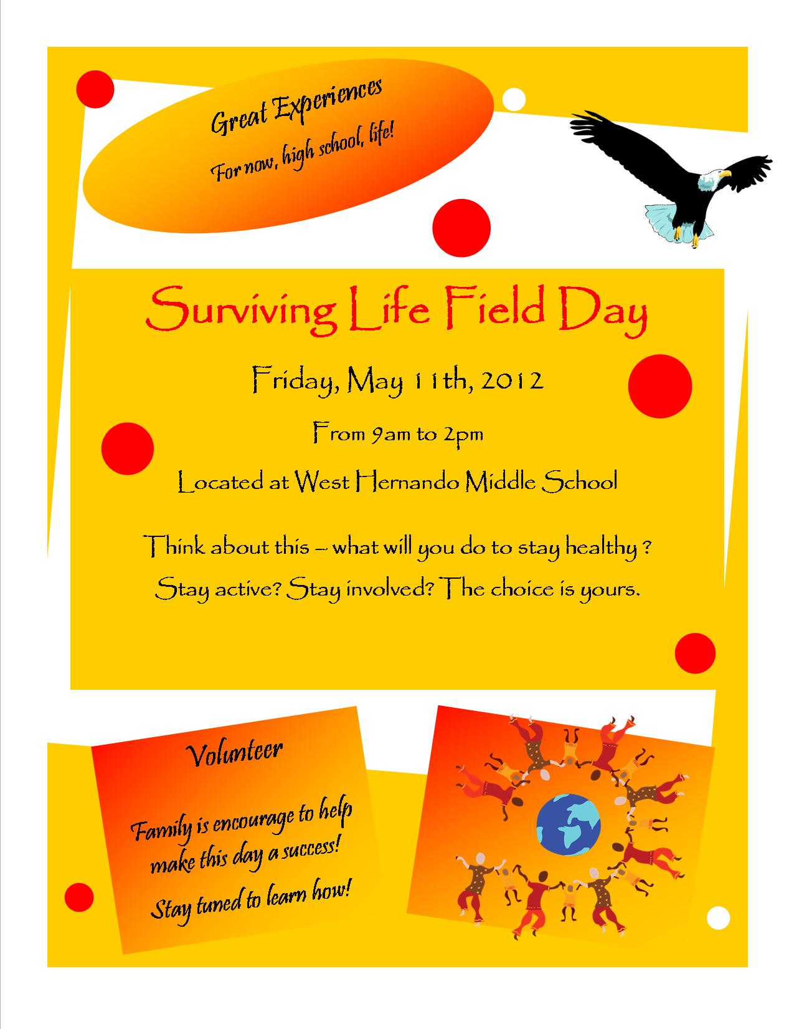
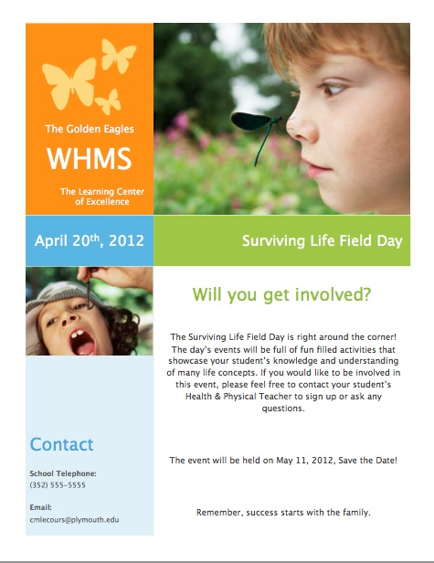
The Learning Center of Excellence
Inspiration Overview

Inspiration Document of the Event

Outline of Inspiration
Inspiration Document of the Event

Inspiration Outline of Surviving Life Field Day

I. Committees
A. Event Day Crew
1. Set-Up
2. Activity Leaders
3. Break-Down
B. Guest Relations
1. Contact Instructors
a. Zumba
b. Tai Chi
C. Builder
1. Design Equipment
a. Gather Materials
(1) Build Equipment
D. Publicity
1. Create Ads
2. Publicize Ads
E. Snack
1. Decide Recipes
2. Gather Ingredients
a. Donations
b. Cafeteria
3. Cook
II. Who, What, When, Where
A. 8th Grader Students
B. Experiential Health Concepts
C. May 11th, 2012
9am-2pm

D. School Grounds
1. Gym
2. Classrooms
a. Health Ed
b. Home Economics
c. Homeroom
d. Study Hall
3. Butterfly Garden
4. Fields
a. Softball
b. Practice Softball
c. Practice Football
5. Tennis Courts
6. Nature Trail
7. Bus Loop

