7th Grade - Content Analysis
Muscles
Extension | Refinement | Application
- Where is the rectus abdominal? | 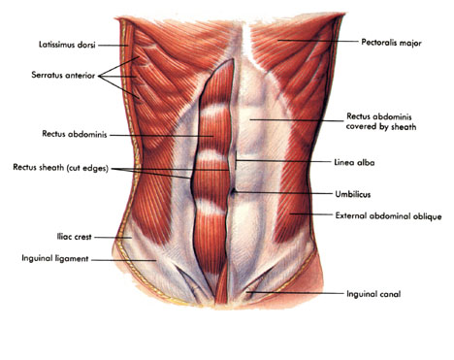 | - Lecture  - Cardio boxing  - DDR  - Discussion
- Where is the external abdominal oblique? |  | - Lecture  - Cardio boxing  - DDR  - Discussion

- Where is the deltoid? | 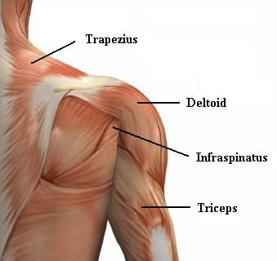 | - Lecture  - Cardio boxing  - DDR  - Discussion
- Where are the triceps? |  | - Lecture  - Cardio boxing  - DDR  - Discussion

Dribbling a Basketball
Extension | Refinement | Application
- Dribbling a basketball | - Student lets the ball go above the hand and waist 1-2 times.  - Student looks down at the basketball 1-2 times.  - Student uses the palm of the hand 1-2 times to dribble the basketball.  - Student commits a traveling or double dribble violation 1-2 times. | - Discussion  - Valleys & Mountains  - Closure  - Any activity done with Mrs. Savage

