Nutrition Test #2

Name:______________________________

Date:_____________ Class: _____________

Score: _____ / 50

Multiple Choice

(3 points per answer – 21 points total)

*Circle the correct answer*

1. Breakfast is important because ________
   1. Pop-tarts are awesome
   2. Your body needs to refuel itself with energy
   3. It is only important if you wake up before 10 in the morning
   4. Should always be “traditional”
2. An example of a **healthy** snack is ________
   1. Frozen juice bar
   2. Pretzels
   3. 3 cups of air-popped popcorn
   4. All of the above
3. When eating at a restaurant, you should always pay attention to ________
   1. Portion size
   2. The table next to you
   3. What you will eat later
   4. Both A and C
4. On a nutrition label, **how** are the ingredients listed?
   1. From the lightest *(weight)* to the heaviest amount
   2. From the best to worst tasting
   3. From the largest amount *(volume)* to the smallest amount
   4. From the heaviest *(weight)* to lightest amount
5. Product labeling states the potential for?
   1. Health risks
   2. Prizes
   3. Health benefits
   4. Weight gain from eating the product
6. *“Sell-by date”* means that ________
   1. It is the last day you should use the product
   2. The last date the product should be sold
   3. You can personally store and use the product after the “sell-by date”
   4. Both B and C
7. Which of the following are a part of the 4 steps to keep food safe?
   1. Clean and Separate
   2. Cook
   3. Chill
   4. All of the above

Matching

(2 points per answer - 14 Points total)

Write the correct letter (definition) on the line of the matching word

*Each definition is only used once*

1. Food Additives –_____
2. Expiration Date –_____
3. Freshness Date –_____
4. Pack Date –_____
5. Sell-By Date –_____
6. Food Allergy –_____
7. Foodborne Illness -_____
8. The last date you should use the product.
9. The date in which the food was packaged.
10. A condition in which the body’s immune system reacts to substances in some foods.
11. Substances intentionally added to food to produce a desired effect
12. Food poisoning
13. The last date a food is considered to be fresh
14. The last date the product should be sold. You can store and use a product after this date.

Make a List

(2 points per word - 12 Points total)

Write the answers on the lines below the question. One answer per line.

1. List 3 things to be aware of when eating out. Use examples from class and the book

____________________, ____________________, ____________________,

1. List 3 people, which were discussed in class or in the book, which can help with nutritional goals.

____________________, ____________________, ____________________.

Smart Choice

(2 Points for the correct label & 2 points for each correct reason - 8 Points Total)

Circle which food label is overallhealthier

*AND*

List & Describe 3 specific reasons why your choice is overall healthier

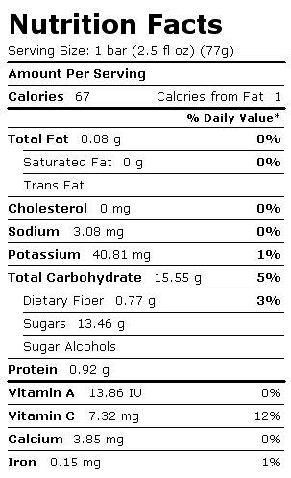 OR 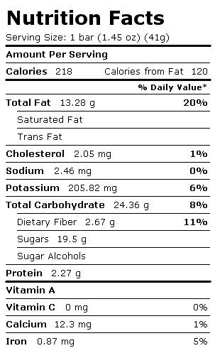

1.

2.

3.

http://quitehealthy.com/nutrition-facts/

Essay

(5 Points Total)

You may write in sentence OR bullet form

1. List **AND** Describe the ABC’s of good health.

**ANSWER GUIDE**

Nutrition Test #2

Name:______________________________

Date:_____________ Class: _____________

Score: _____ /

Multiple Choice

(3 points per answer – 21 points total)

*Circle the correct answer*

1. Breakfast is important because ________
   1. Pop-tarts are awesome
   2. Your body needs to refuel itself with energy
   3. It is only important if you wake up before 10 in the morning
   4. Should always be “traditional”
2. An example of a **healthy** snack is ________
   1. Frozen juice bar
   2. Pretzels
   3. 3 cups of air-popped popcorn
   4. All of the above
3. When eating at a restaurant, you should always pay attention to ________
   1. Portion size
   2. The table next to you
   3. What you will eat later
   4. Both A and C
4. On a nutrition label, **how** are the ingredients listed?
   1. From the lightest *(weight)* to the heaviest amount
   2. From the best to worst tasting
   3. From the largest amount *(volume)* to the smallest amount
   4. From the heaviest *(weight)* to lightest amount
5. Product labeling states the potential for?
   1. Health risks
   2. Prizes
   3. Health benefits
   4. Weight gain from eating the product
6. *“Sell-by date”* means that ________
   1. It is the last day you should use the product
   2. The last date the product should be sold
   3. You can personally store and use the product after the “sell-by date”
   4. Both B and C
7. Which of the following are a part of the 4 steps to keep food safe?
   1. Clean and Separate
   2. Cook
   3. Chill
   4. All of the above

Matching

(2 points per answer - 14 Points total)

Write the correct letter (definition) on the line of the matching word

*Each definition is only used once*

1. Food Additives –__D__
2. Expiration Date –__A__
3. Freshness Date –__F__
4. Pack Date –__B__
5. Sell-By Date –__G__
6. Food Allergy –__C__
7. Foodborne Illness -__E__
8. The last date you should use the product.
9. The date in which the food was packaged.
10. A condition in which the body’s immune system reacts to substances in some foods.
11. Substances intentionally added to food to produce a desired effect
12. Food poisoning
13. The last date a food is considered to be fresh
14. The last date the product should be sold. You can store and use a product after this date.

Make a List

(2 points per word - 12 Points total)

Write the answers on the lines below the question. One answer per line.

1. List 3 things to be aware of when eating out. Use examples from class and the book

____________________, ____________________, ____________________,

Fried, baked, or broiled; Topped with mayonnaise, butter, or high-fat sauces; Nutritional information; Portion size; Foods you will eat for the remainder of the day

1. List 3 *professional* people, which were discussed in class or in the book, which can help with nutritional goals.

____________________, ____________________, ____________________.

Doctor, Nurse, Nutritionist, Physical Education Teacher, Health Education Teacher, School Cafeteria Personal

Smart Choice

(2 Points for the correct label & 2 points for each correct reason - 8 Points Total)

Circle which food label is overallhealthier

*AND*

List & Describe 3 specific reasons why your choice is overall healthier

 OR 

Less calories from fat; 0% Saturated Fat, Cholesterol; Less sugars; More Vitamin A & C; Larger portion but healthier

http://quitehealthy.com/nutrition-facts/

Essay

(5 Points Total)

You may write in sentence OR bullet form

1. List **AND** Describe the ABC’s of good health.

A: Aim for Fitness

* Discusses:
  + Fitness goals
  + Healthful eating
  + The importance of regular physical activity
  + Aiming for a healthy weight that makes you feel & look good

B: Build a Healthy Base

* Discusses:
  + Building a healthful eating plan
  + Use of the current food pyramid
  + Making careful food choices (ex: Eating the correct servings)
  + Whole grains
  + Variety of fruits and veggies
  + Keeping food safe
  + Serving Size

C: Choose Sensibly

* Discusses:
  + A diet with low cholesterol/sodium/ect
  + Choosing beverages that limit the intake of sugars
  + Using less salt
  + Moderation in fats