**Ticket to Class**

**Nutrition Ticket #4**

**___/20 Points**

***Fill in the answers and list the page numbers used to answer the question***

1. Label and explain, in your own words, the food label below. This label is for a medium french fry from McDonald’s.

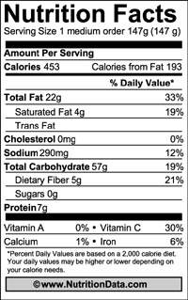

1. How are ingredients put in order on the label? _____________
2. What is a food additive? And give 3 reasons why it might be added to food.
3. Labels add all sorts of words to the front of the label to show how the product is a healthier version of the original. From the listed words below, write in what the definition is **AND** what you think of when you hear or read the labels when at the store.

|  |  |  |
| --- | --- | --- |
| **Word on Label** | **What it means** | **What you think when you hear/see it** |
| **Light or Lite** |  |  |
| **Less** |  |  |
| **Free** |  |  |
| **More** |  |  |
| **High, Rich In, or Excellent Source of** |  |  |
| **Lean** |  |  |

1. List and explain the 4 Open Dating categories.
2. _____________ is a condition in which the body’s immune system reacts to substances in some foods. These substances that they are allergic to can also be called an _____________.
3. List 5 reactions the body can have from a food allergy
4. Define food intolerance
5. What is a food-borne illness?
6. List 2 ways that a food-borne illness can happen
7. List and explain 4 ways to help prevent food-borne illness