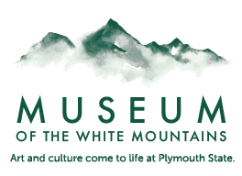Turning a Molehill into a Mountain

Learning Outcomes:
- Students will understand the basics of topography as well as basic mountain formations.
- Students will be able to explain what causes erosion and the formations of ravines in mountains.
- Students will be able to envision a mountain and be able to take that vision and create a reality.
- Students will be able to verbally explain the links between science and art when it comes to mountains.

Directions:
- Have students break into equally small groups and allow them to wander the Museum with guided questions about the mountains they are looking at.
- Ask the students to take their time and to really think about the questions.
  - Ask the students to take their time and to really think about the questions.
  - Have questions such as How many miles tall do you think the mountains are?
  - How about how many miles wide?
  - Without a trail could we cross the mountain?
  - How old do the mountains look?
  - How old do they think they are?
- Talk with the students about the differences in two dimensions and three.
- Ask the students if they know how we draw something large and irregular in two dimensions.
- Try to lead the conversations towards topography although the name may be unheard of at this time.
- Split the students into groups and ask them each to draw a potato half as best as they are able while giving as much information about the shape of the 3D object but only drawing 2D.
- Afterward, have the groups share out what they came up with and how they drew the potato.
- Next, give the students a thinly sliced potato half and ask them to draw that on a piece of paper.
  - Give hints that the potato is sliced for a reason and they should try to use that to their advantage.
- Review with the student what they came up with and show them the best way to make their own topographic map. Explain what these types of maps are and why they are to widely used today.
- Next, have the students transfer into the creation of their own mountains
- Ask the students to work in groups and to create a drawing and a topographical map of a dream mountain for the group.
- The mountain should include things such as rivers valleys and possibly even lakes
- After they have completed all of this begin the guided formation of their very own mountains.
  - See instructions below.
  - These would either need to be taken back still drying or be picked up at a later date. Or dropped off?
  - Once they are dry they as a group or a class can paint them to look like a real mountain.
- Recap based on the learning outcomes to assess the level of achievement and learning from the group.

In the event of loss of group use this list of games to refocus the students on Science
- Science Guess Who
  - Tape names of science things on the back of each student and have them wander asking yes or no questions trying to figure out what they are.
- Print Closeups of everyday objects and have them try to figure out what they are in groups.
- Herbivore tag (Place emphasis on the slow nature of this game)
  - Students are either grass (Who move extremely slowly as we all know) or a slow lethargic moose who just wants to eat some grass.
  - If/when a student is tagged they become scat and they stand with a thumbs up on top of their other open palm.
  - Two other pieces of grass can save the scat by holding hands around them and chanting “Decompose and break it down”.
  - Now the scat is once again grass.
    - Try having too many deer or not enough grass.
    - What happens to an ecosystem when this happens?

Step 1
Find a sturdy base made of wood or cardboard that is wider than the size you want your finished mountain to be.
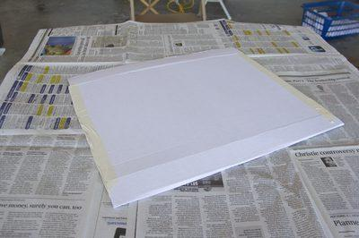
Choose a base for the mountain model.

Step 2
Sketch a rough image of the mountain you have in mind. Think about how steep you want it, how many peaks you want, and estimate the overall height and width.
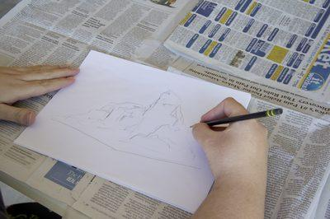
Draw the mountain.

Step 3
Crumple large sheets of aluminum foil loosely to create a frame for the structure. Shape the foil the way you want your mountain to be shaped, making peaks and valleys. Let the shape taper off so it spreads out naturally. Glue the foil structure to the base, molding it and forming it, adding more foil if necessary, until you are satisfied with the shape.
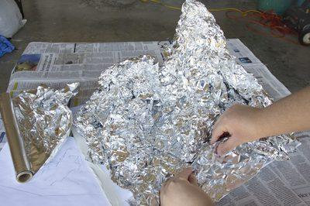
Create a frame with foil.

Step 4
Cover the entire foil mountain frame with a layer of paper packing tape. This helps to hold the shape and provide a smooth, absorbent surface for the paper mache to adhere to.
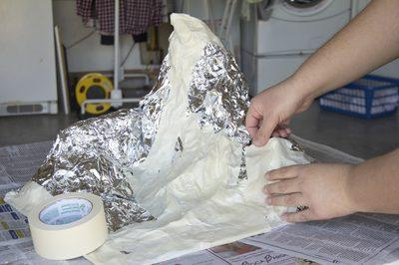
Use paper packing tape to hold the frame together.

Step 5
Pour a gallon of warm water into a large plastic bin. Cut or tear newspaper into 1-inch to 2-inch squares. Add enough newspaper scraps to the water until you have a soupy mixture.
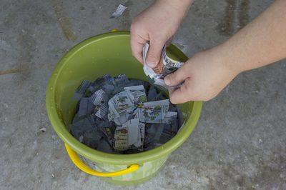
Make paper mache.

Step 6
Pour 2 to 3 cups of the mixture into a blender and puree the paper. Add more water if the mixture is too thick. Pour the pureed mixture into a fine sieve to drain away excess water, then place the paper mache pulp into a large bowl.
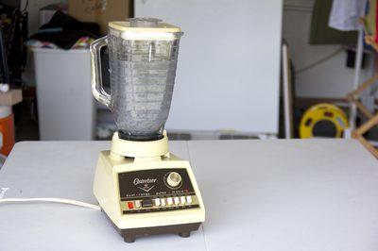
Make paper mache pulp with a blender.

Step 7
Puree the rest of the paper into pulp in 2- to 3-cup increments and add the pulp to the bowl. Mix the paper mache pulp with white craft glue and 1/4 cup of table salt until it's thick, wet and pasty, like the consistency of creamy oatmeal.
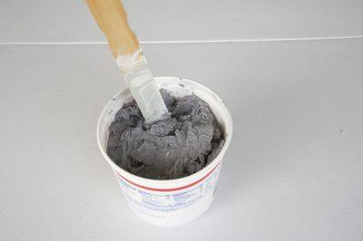
Paper mache puree should look and feel like oatmeal.

Step 8
Scoop some of the pulp in your hand and begin spreading it over the mountain shape. Start from the bottom at the base and work your way up the mountain peaks.
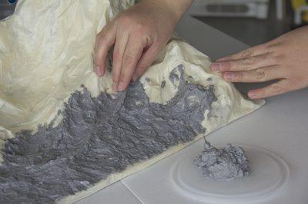
Form the mountain with paper mache.

Step 9
Add details to the mountain with the paper pulp if desired. Create ridges by making a thin line of pulp and pinching it. Put two ridges next to each other to look like a stream. Make small foil balls and cover them to create boulders. Allow the structure to dry overnight once you are satisfied with it. Preserve the leftover paper pulp in a sealed plastic storage bag in the refrigerator.
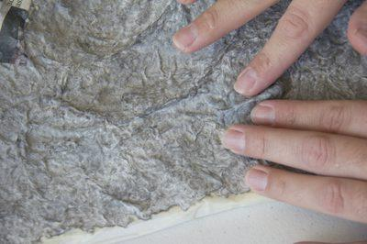
Enhance the model with details.

Step 10
Paint the mountain with acrylic paints. Think about which direction the light would hit it, and use a lighter color on that side. Paint the other side with a color that's two or three shades darker to indicate shadows. Paint details, such as blue streams and a white snow cap.
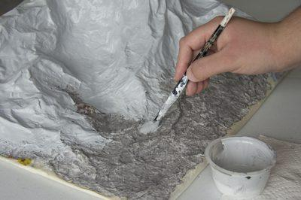
Paint the model as needed.

